**Application Deployment**

**Step:1**

*Launch 2 instances and name it as Build and Deploy.

*Install java

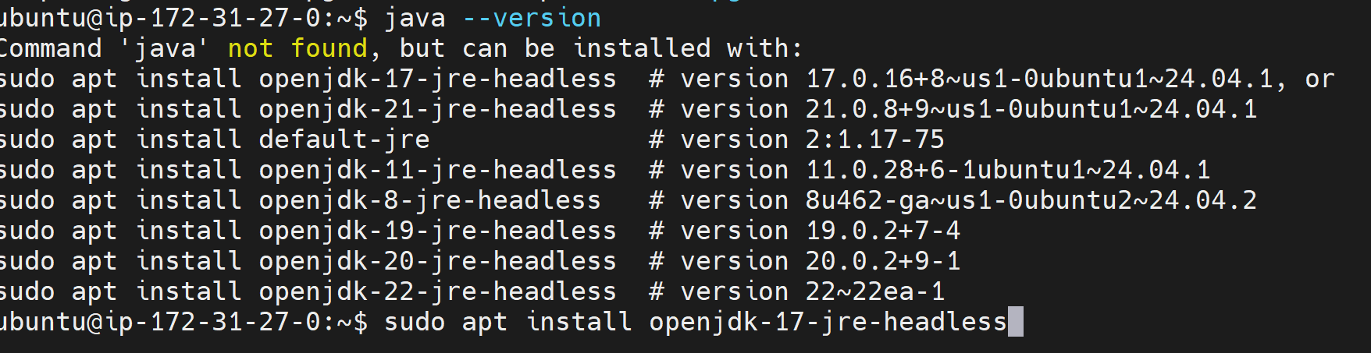

*Install maven



*Clone the code from github.

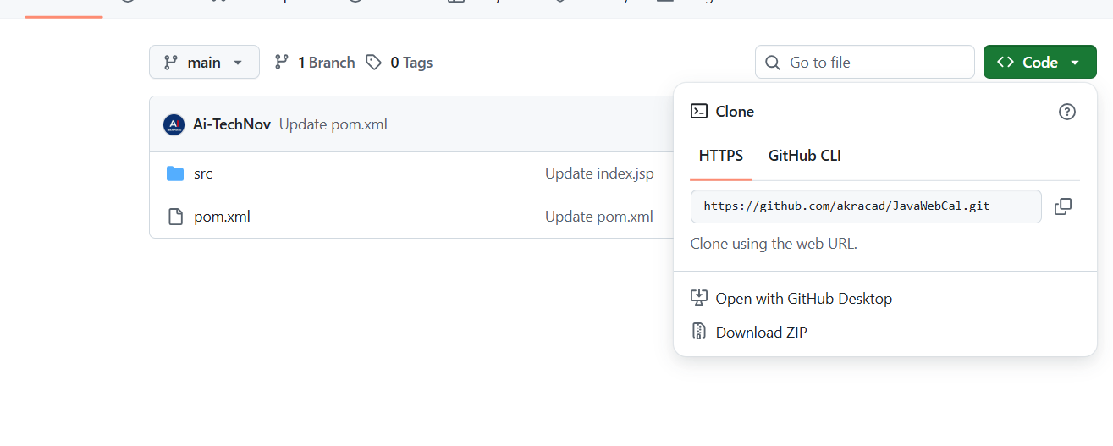



*mvn package

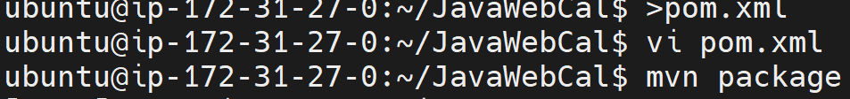

*Here the build will be Success.

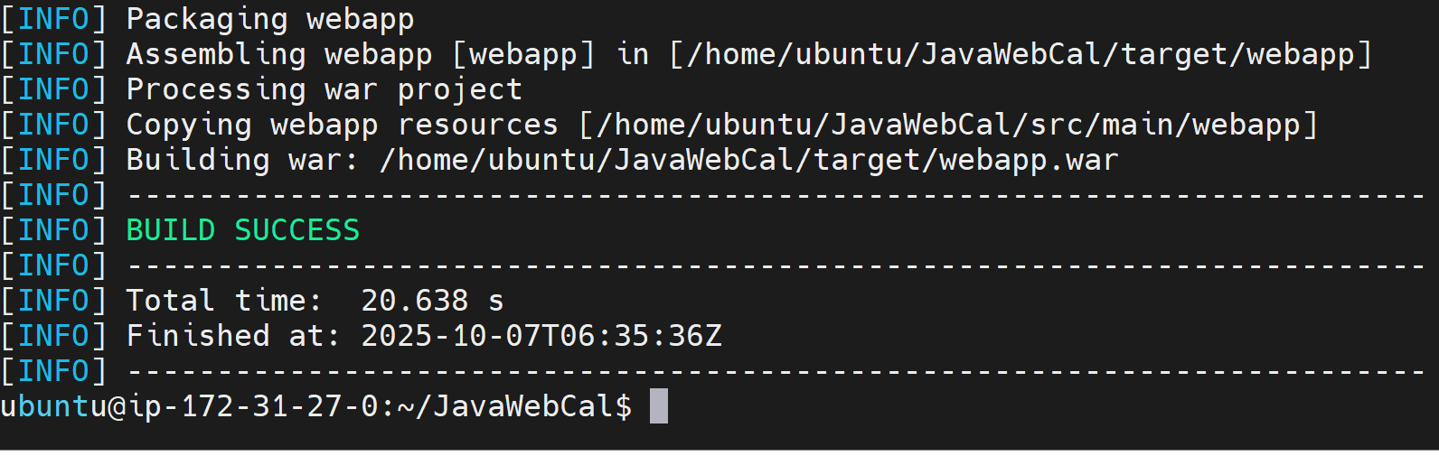

**Step :2**

Take another server named as (Deploy).

*Here we need to install Java and Tomcat.

*Install java.



*Install Tomcat.



🡪untar the tomcat.

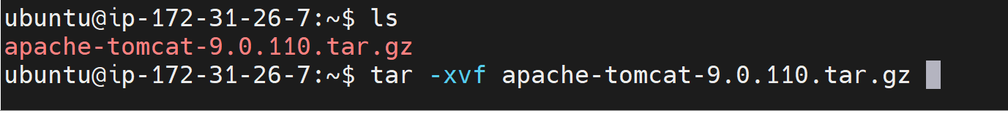

🡪Rename it.

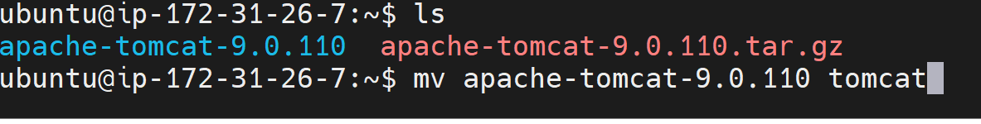

🡪Comment in webapps/host manager and manager /META/context.xml





* Change the password in conf/tomcat-user.xml

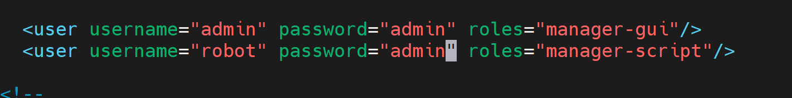

🡪Give port number in Security group as 8080

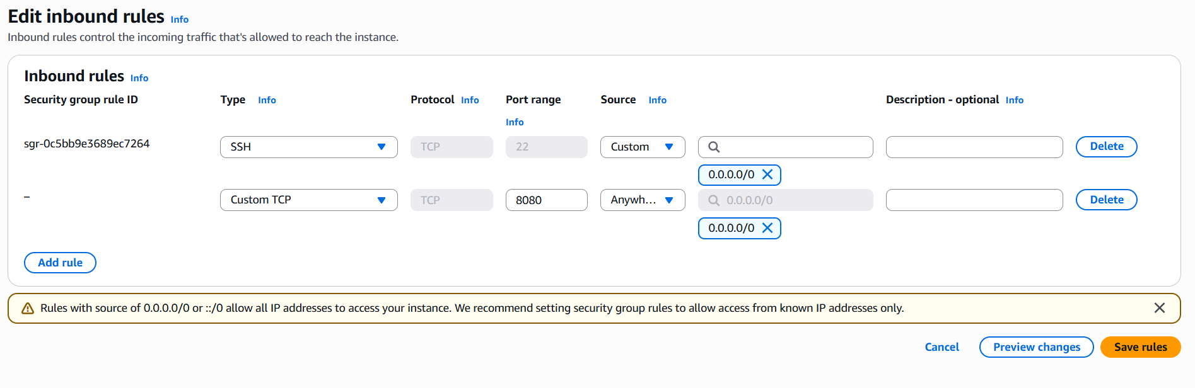

🡪Start tomcat

./start.sh

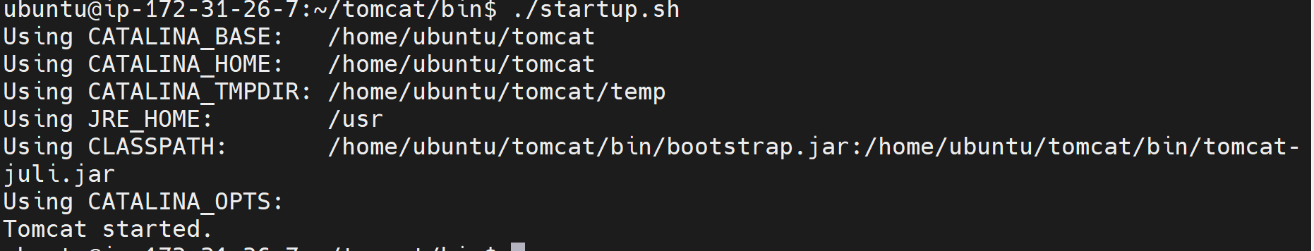

🡪Access Tomcat in web browser with public ip and port number.

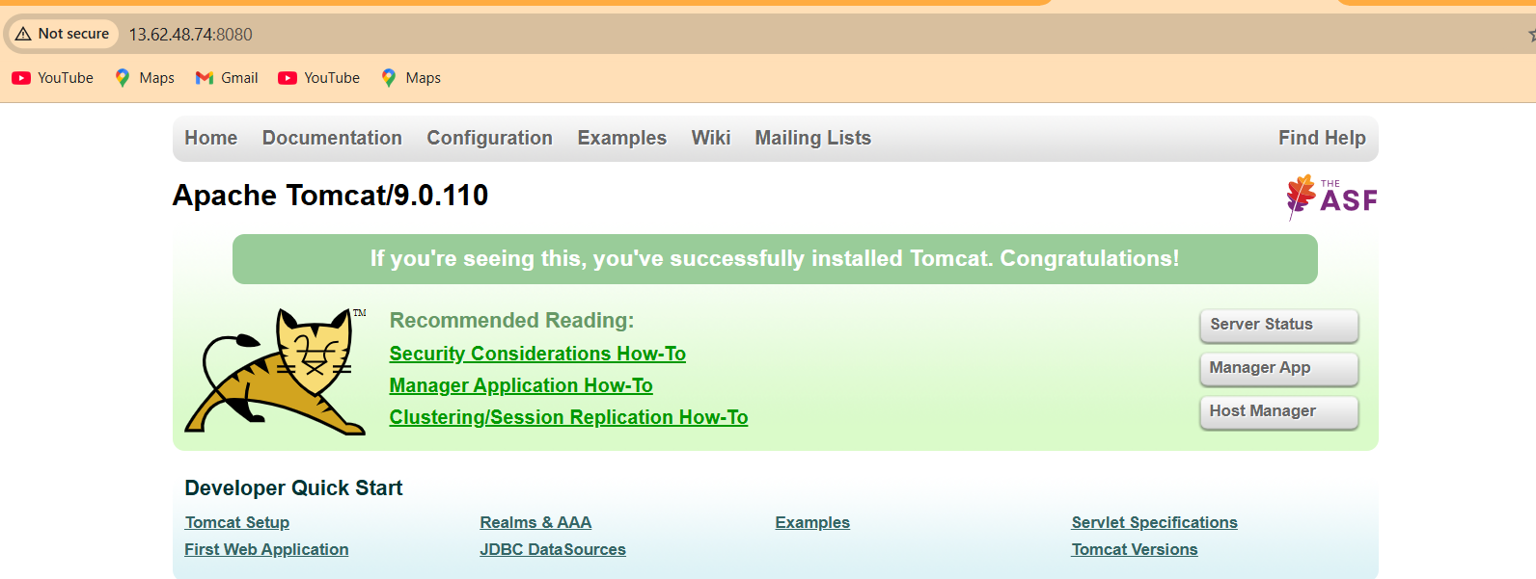

🡪Login to Manager with username and password(admin)

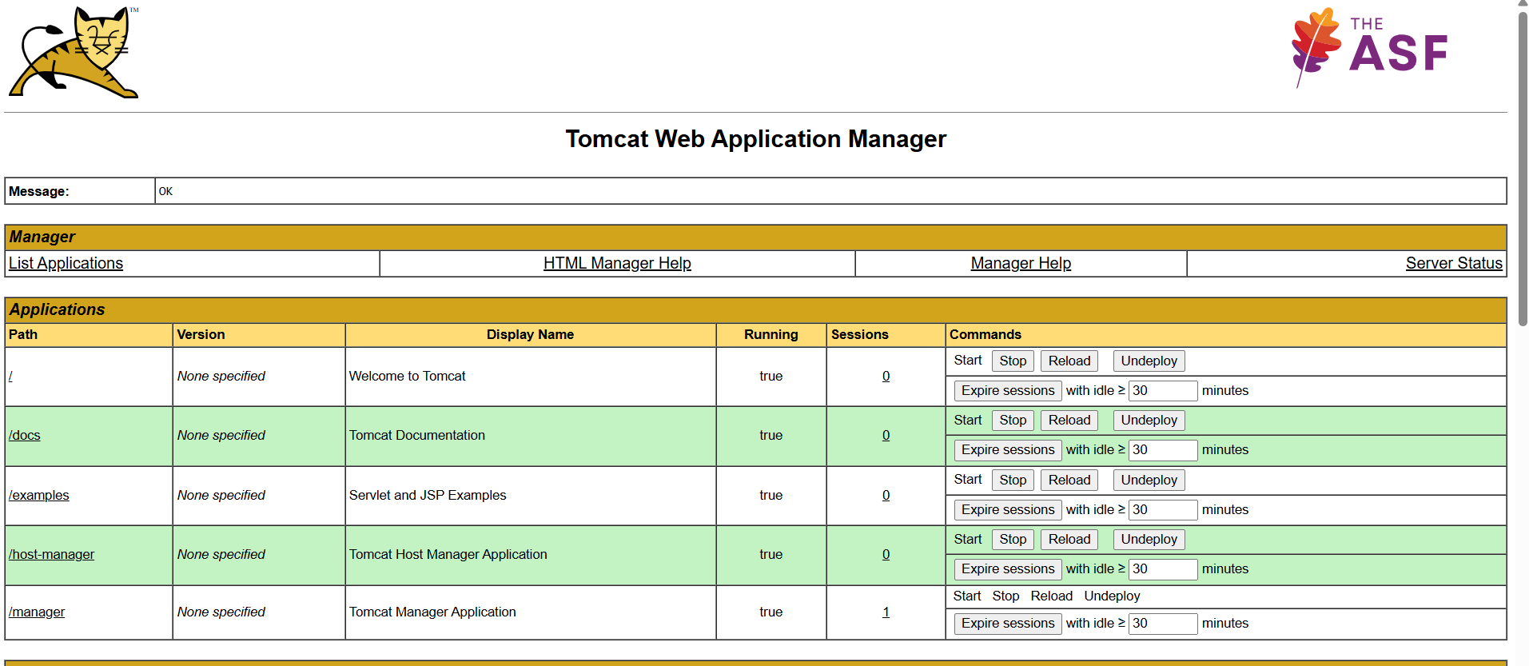

Step :3(Build server).

* Create ssh-keygen
* Cat public id generated
* Copy the public key and paste it in Deploy server (Authorized keys.

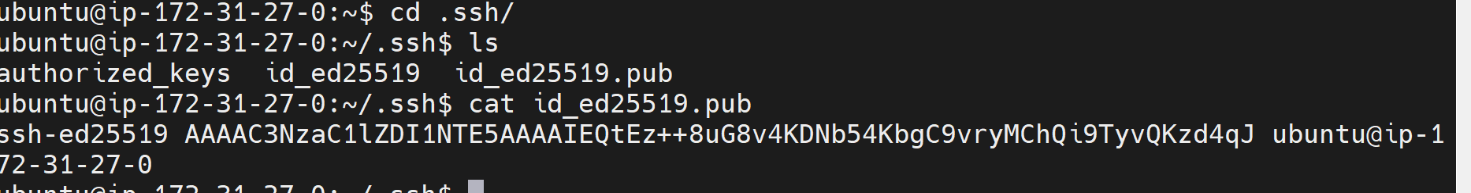

**Step:4(Deploy server)**

*Go to .ssh

*vi authorized keys paste the keys generated in Bulid server.

**Step:5**

*Copying the War file from Build server to Deploy server.

(scp /home/ubuntu/Javawebcal/target/*.war ubuntu@deploy-public-ip:/home/ubuntu/tomcat/webapps).





